Hamida Farhan Al-Harsheh’s poem to her missing brother

Format: Co-creation with Hamida who wrote a poem for her missing brother. Hamida guided us on the visual approach and validated the product

Hamida, the poet, guided me, as well as the delegation, on the visual approach and the shots chosen. It is her voice
(in the Arabic version) and her poem that we have illustrated. Big thank you to @rafah and fahar for the suggestion
and guidance

What does co-creation really mean?

While co-creation is adding another layer of input/opinion and validation to a piece of content, the value of having the person affected shape their story and humanize their experience feels the right approach.
For more information on co-creation, this Creative Content Meeting was very interesting: The people in the pictures: Researcher Jess Crombie on co-creation
Colour palette: Red + olive green
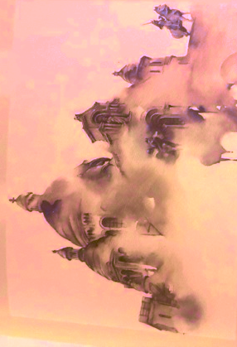
Ink splashes - paper printed letters

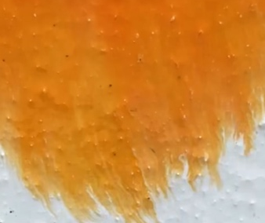
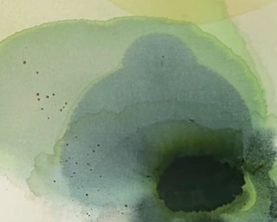
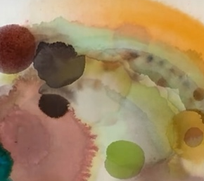
Inspiration:

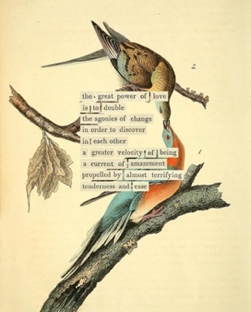
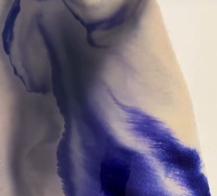
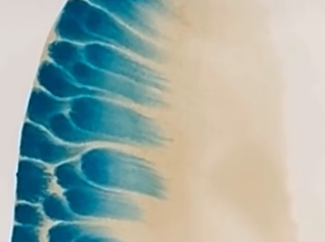
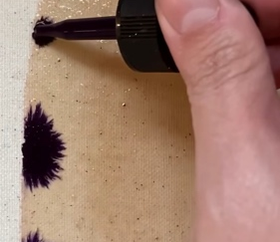

Title: Hamida’s poem to her missing brother | Paths to peace

Intro text:
Hamida was 10 years old when her brother was born. As he grew, she taught him to read and write. When he was afraid of the dark, she would comfort him.

In 2022, he went missing upon returning to Syria. Not knowing his fate caused Hamida unbearable pain. For years, she couldn't speak his name without breaking down - her memories blocked by the trauma of ambiguous loss.

Through mental-health support from the ICRC, Hamida gradually found the strength to cope. She turned her grief into agency, reaching out to support others living with the same pain. While Hamida has since been reunited with her brother, her journey reflects a broader, powerful truth documented in our latest report: families of the missing are not just victims - they are vital agents of peace.

For more information: https://shop.icrc.org/report-missing-persons-and-peacebuilding-the-role-of-families-of-the-missing-…

Words | Images
Poem by Hamida Farhan  whose brother was missing for two and a half years  in the Syrian conflict. | قصيدة لحميدة فرحان  التي كان شقيقها مفقودًا لمدة سنتين ونصف  بسبب النزاع في سوريا
An inexplicable loss, and colours | Beautiful colours disappear as red drops in?  Words look like this?  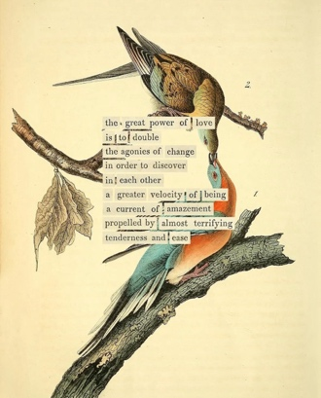
Migration and loss | 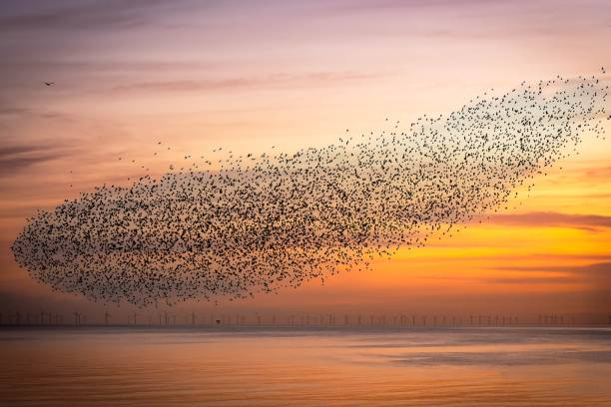  Birds swarm and fade away. (love the colours)
A heartbroken; a mind oppressed | 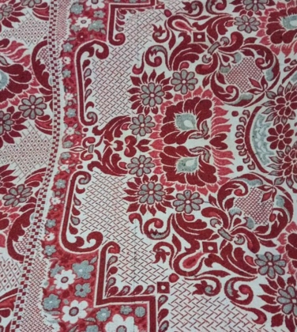  Abstract heart /bars? Not sure what to add here?  Blanket pattern disintegrates?
And bleeding ink | 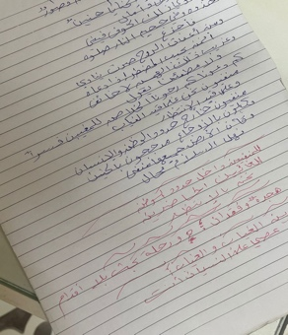  Her words bleed and disappear wit  h water?
A footless journey of search | 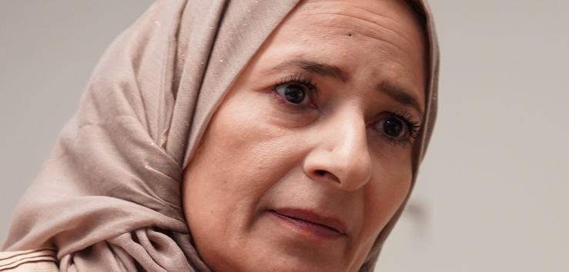  Close up of Hamideh’s eye
Traps hidden in every “if” | ? word if is trapped? In a fisherman’s net
Traps of fear for you, my brother | 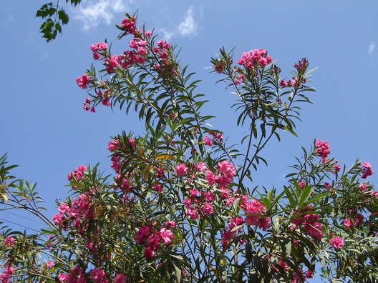  ?? child with lamb.  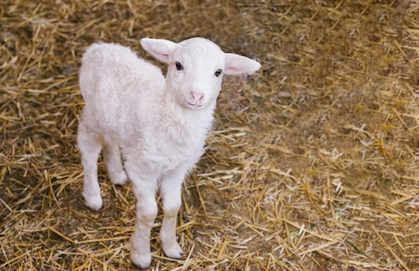  Pomegranate trees, peaches, chickens, lambs  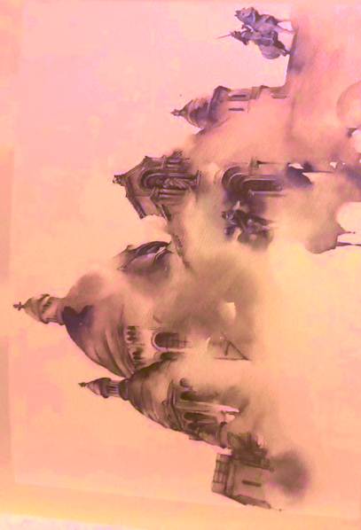  Child waving – merges into darkness? Like this?
Traps of longing for you, in the gardens of memories … | Photos of brother and father to oleander flowers that bleed away?  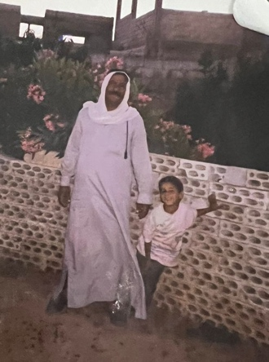  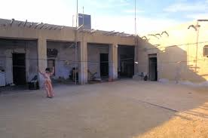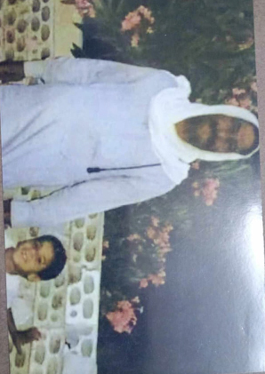
Traps of search and anticipation | ? 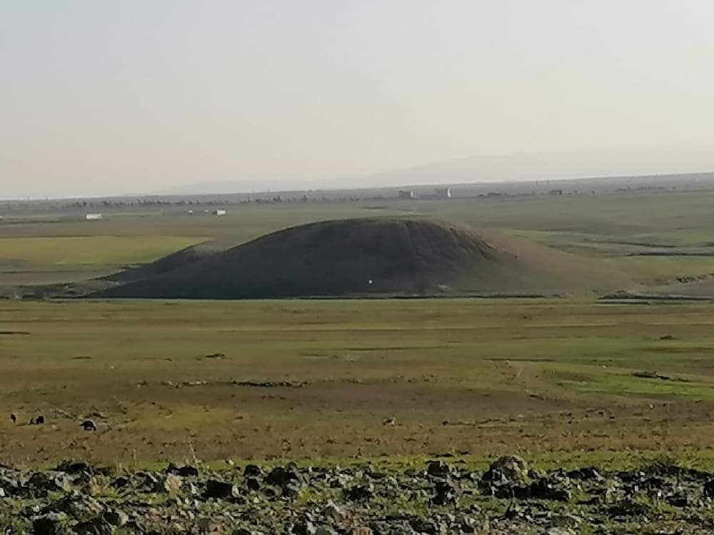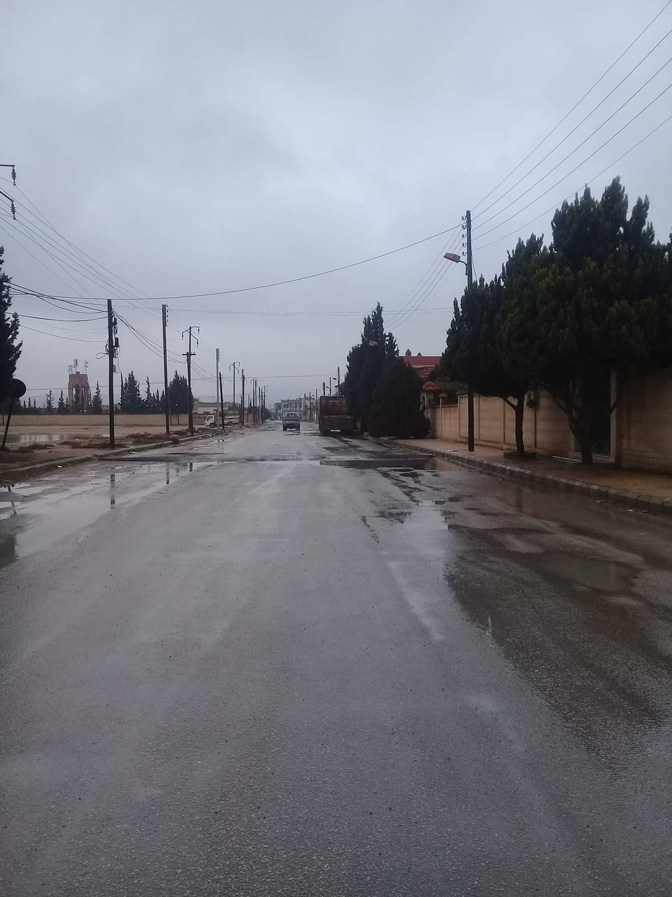
Who, I wonder, will eliminate the pain of entrapment from our hearts? | Just text of the poem
From our homes, pathways, and streets | Video from home
Who will dispel the fears | ICRC + Hamedah
Of solitude and waiting? | Close up of eyes?
And gather the beloved of the missing | Zooms out to crowd
To tell them:

Rest assured, you are not alone | Fades into real photos / videos of Hamideh at ICRC with the mental health teams?
For I am on this quest with you. | Is I here ICRC? Or Hamideh?  Photograph of Hamideh with ICRC
Hamida is now reunited with her brother.  أ | خيرًا، التقت حميدة بشقيقها من جديد.
The ICRC continues to support  families with missing loved ones. | وتواصل اللجنة الدولية للصليب الأحمر تقديم الدعم  للعائلات التي فقدت أحباءها.
International Committee of the Red Cross | اللجنة الدولية للصليب الأحمر  ICRC logo

