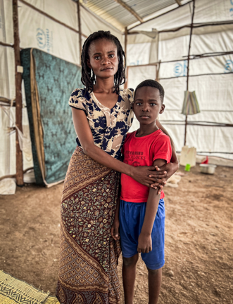

Portrait of Sylvie Zawadi Miranyo with her child. Sylvie doesn’t know what happened to her husband after their house was damaged by an explosion.
Photo : Alphonse Dioh
Country/Location : Musenyi refugee camp in Burundi
Date : March 28, 2025

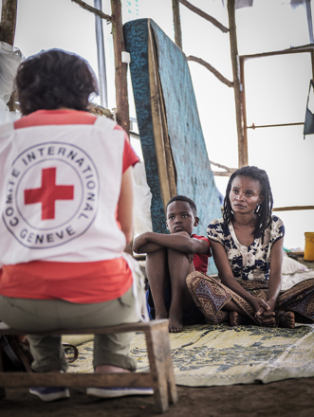

Photo of Sylvie Zawadi Miranyo with her child during the interview.
Photo : Alphonse Dioh
Country/Location : Musenyi refugee camp in Burundi
Date : March 28, 2025

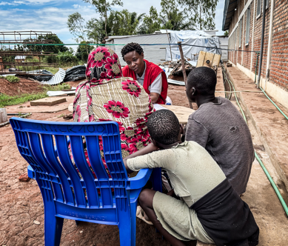
Photo of Noemie Niyongere, at ICRC Protection of Family Links program, is registering separated families
Photo : Alphonse Dioh
Country/Location : Musenyi refugee camp in Burundi
Date : March 28, 2025

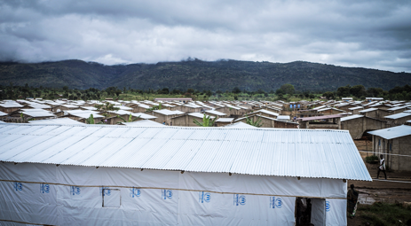
General view of Musenyi refugee camp in Burundi
Photo : Alphonse Dioh
Country/Location : Musenyi refugee camp in Burundi
Date : March 28, 2025

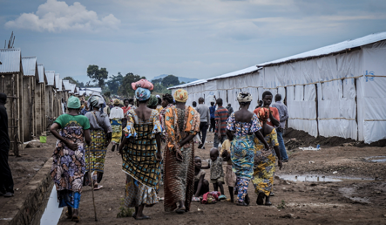
Refugees in Musenyi camp in Burundi
Photo : Alphonse Dioh
Country/Location : Musenyi refugee camp in Burundi
Date : March 28, 2025

Portrait of Daniela Mapendo Santana, a refugee from DRC, with her child. Daniela was separated from her family while fleeing violence in DRC.
Photo : Alphonse Dioh
Country/Location : Musenyi refugee camp in Burundi
Date : March 28, 2025

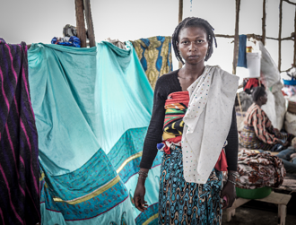
Portrait Daniela Mapendo Santana in her tent
with her child
Photo : Alphonse Dioh
Country/Location : Musenyi refugee camp in Burundi
Date : March 28, 2025
